## Undoing things

# 1- Undo a non-staged change in one of the files

echo ​ "#some changes" ​>> cleaner.py ​ # modify

git ​ checkout cleaner.py ​# undo

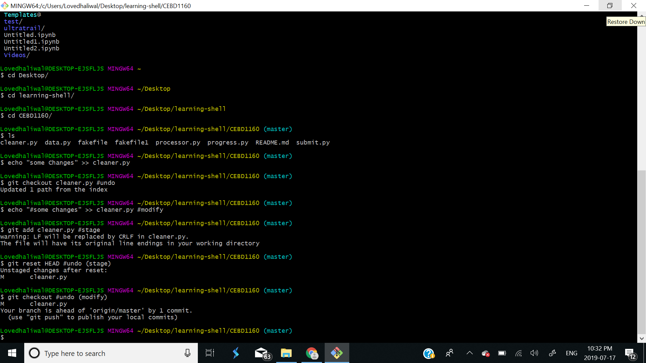

# 2- Undo a staged change in one of the files

echo ​ "#some changes" ​>> cleaner.py ​ # modify

git ​ add cleaner.py ​# stage

git ​ reset HEAD ​# undo (stage)

git ​ checkout . ​# undo (modify)



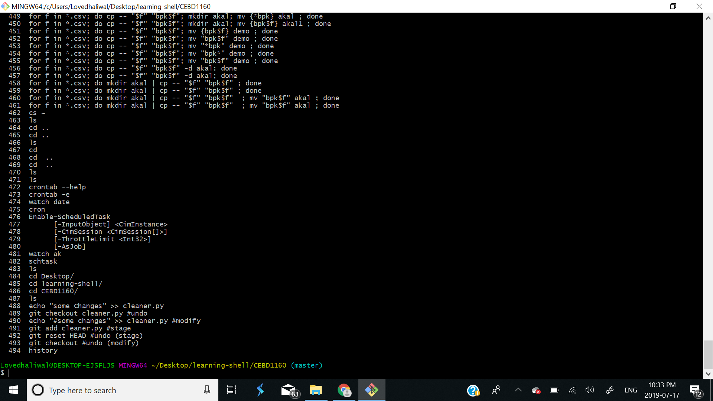

# 3- Undo a committed change in one of the files

echo ​ "#some changes" ​>> cleaner.py ​ # modify

git ​ add cleaner.py ​# stage

git ​ commit -m​"make changes staged" ​# commit

git ​ reset --hard HEAD~1 ​# undo

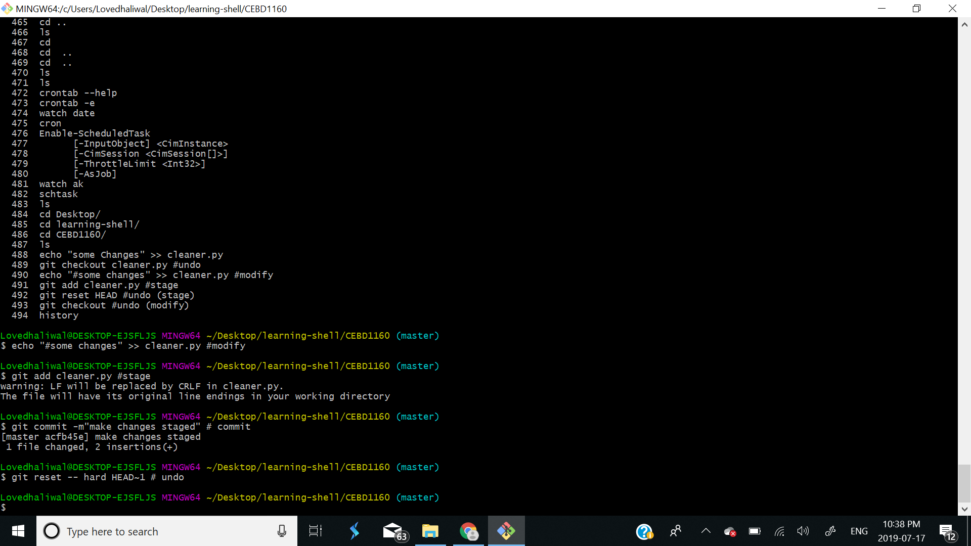

# 4- Reset your master branch to an older commit (your changes will be lost, add a new fake commit if you don’t want to lose it!) touch ​ fakefile git ​ add fakefile git ​ commit -m​"adding fake file" git ​ log --pretty=oneline older_commit=​$​(git log --pretty=oneline | grep "Adding remaining files" | cut -d' ' -f1) git ​ reset --hard ​$​{older_commit} ​# undo

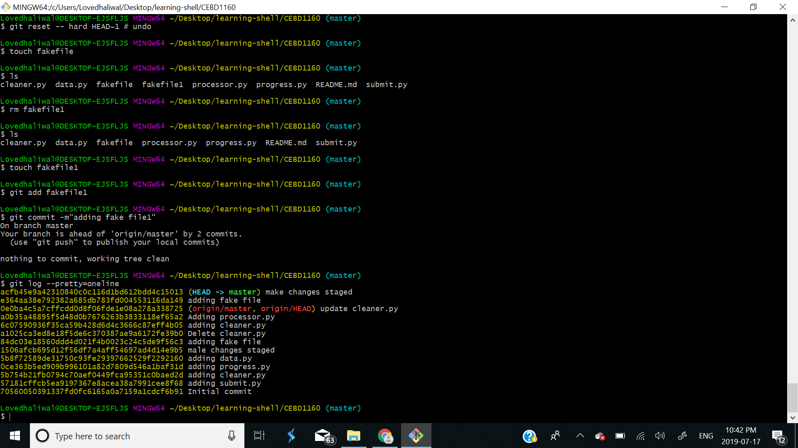

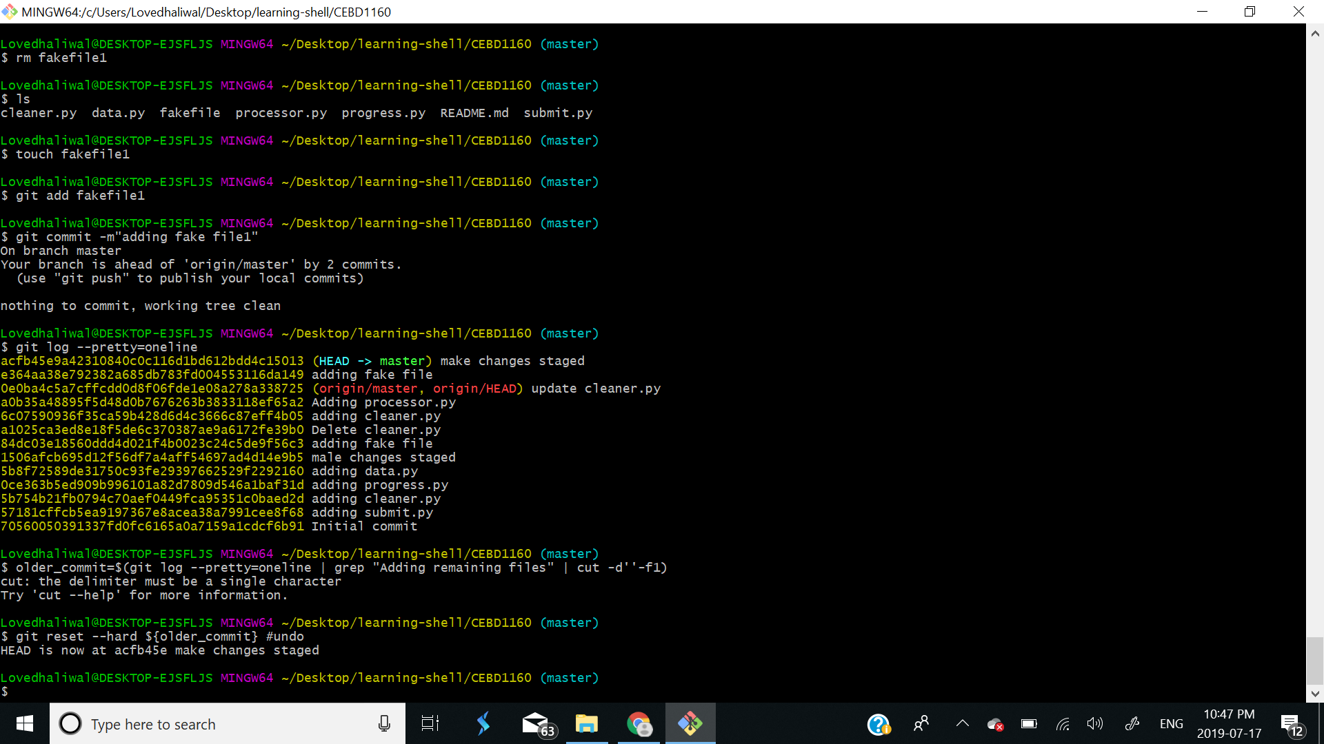

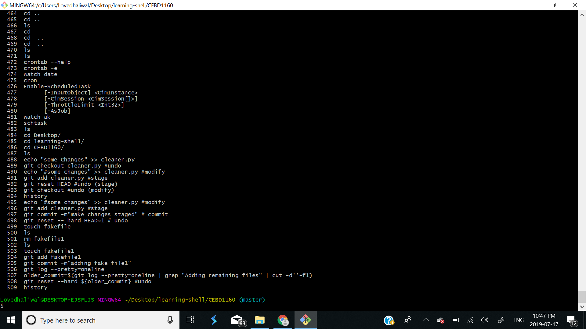

## Create a branch to split your development

# 1- Create a branch called new-data and add a commit to it with a new file called data2.csv.

git ​ checkout -b new-data master

echo ​ "# data2.csv content" ​> data2.csv

git ​ add data2.csv

git ​ commit -m ​"adding data2.csv"

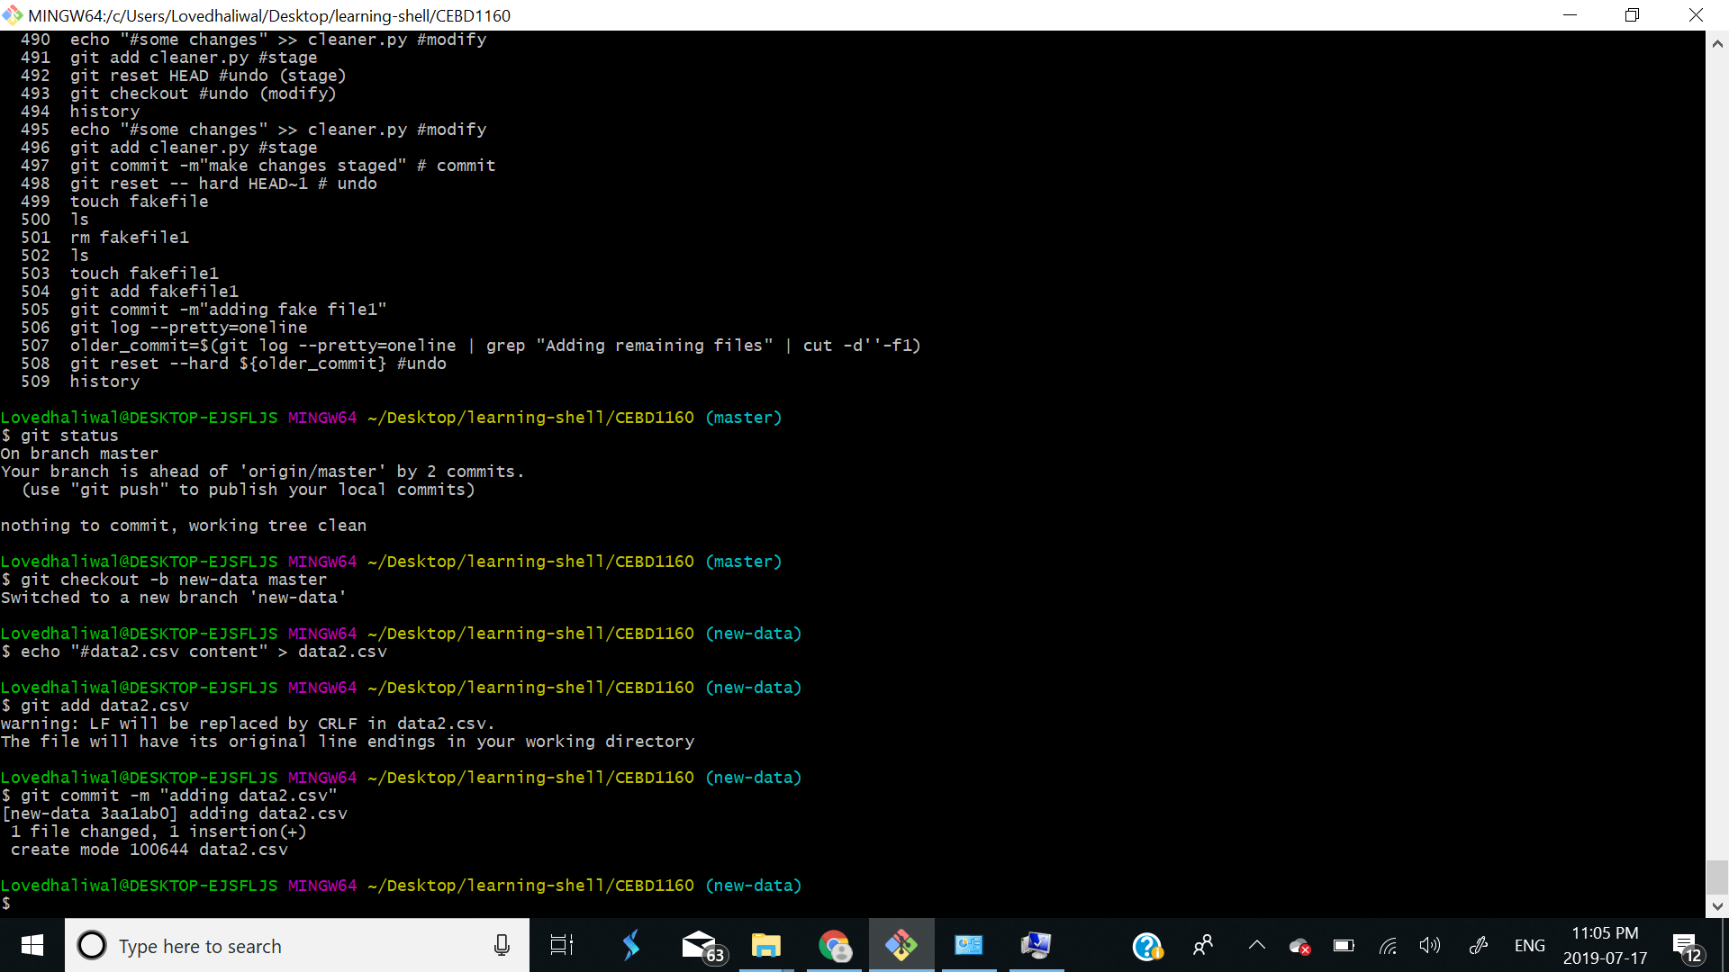

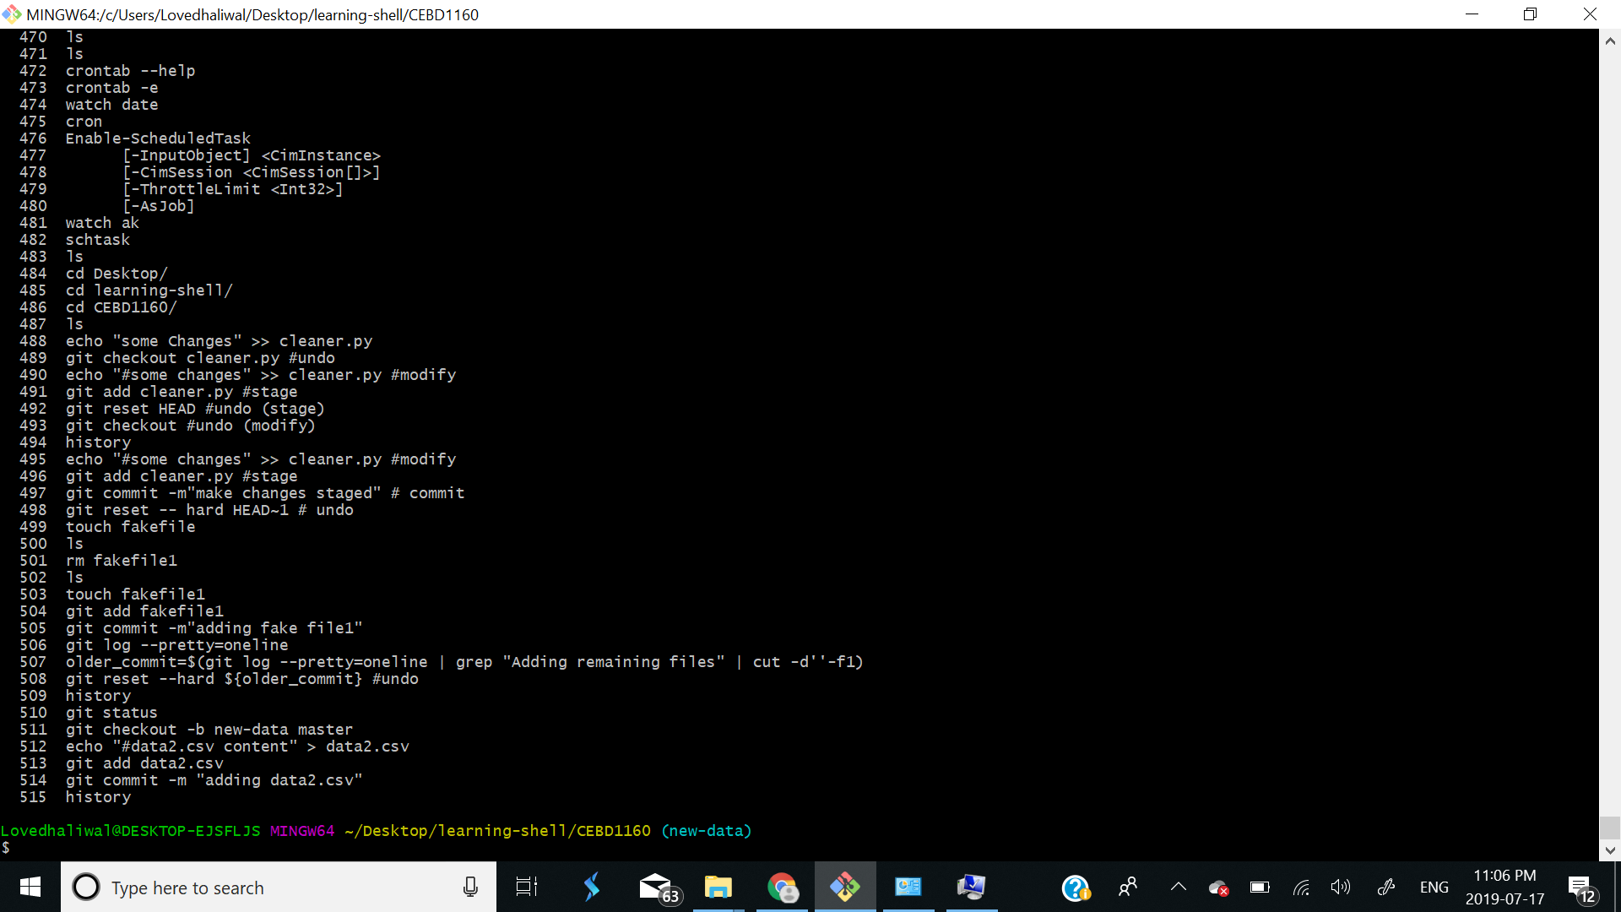

# 2- Checkout your master and check the files that you see.

git ​ checkout master

ls

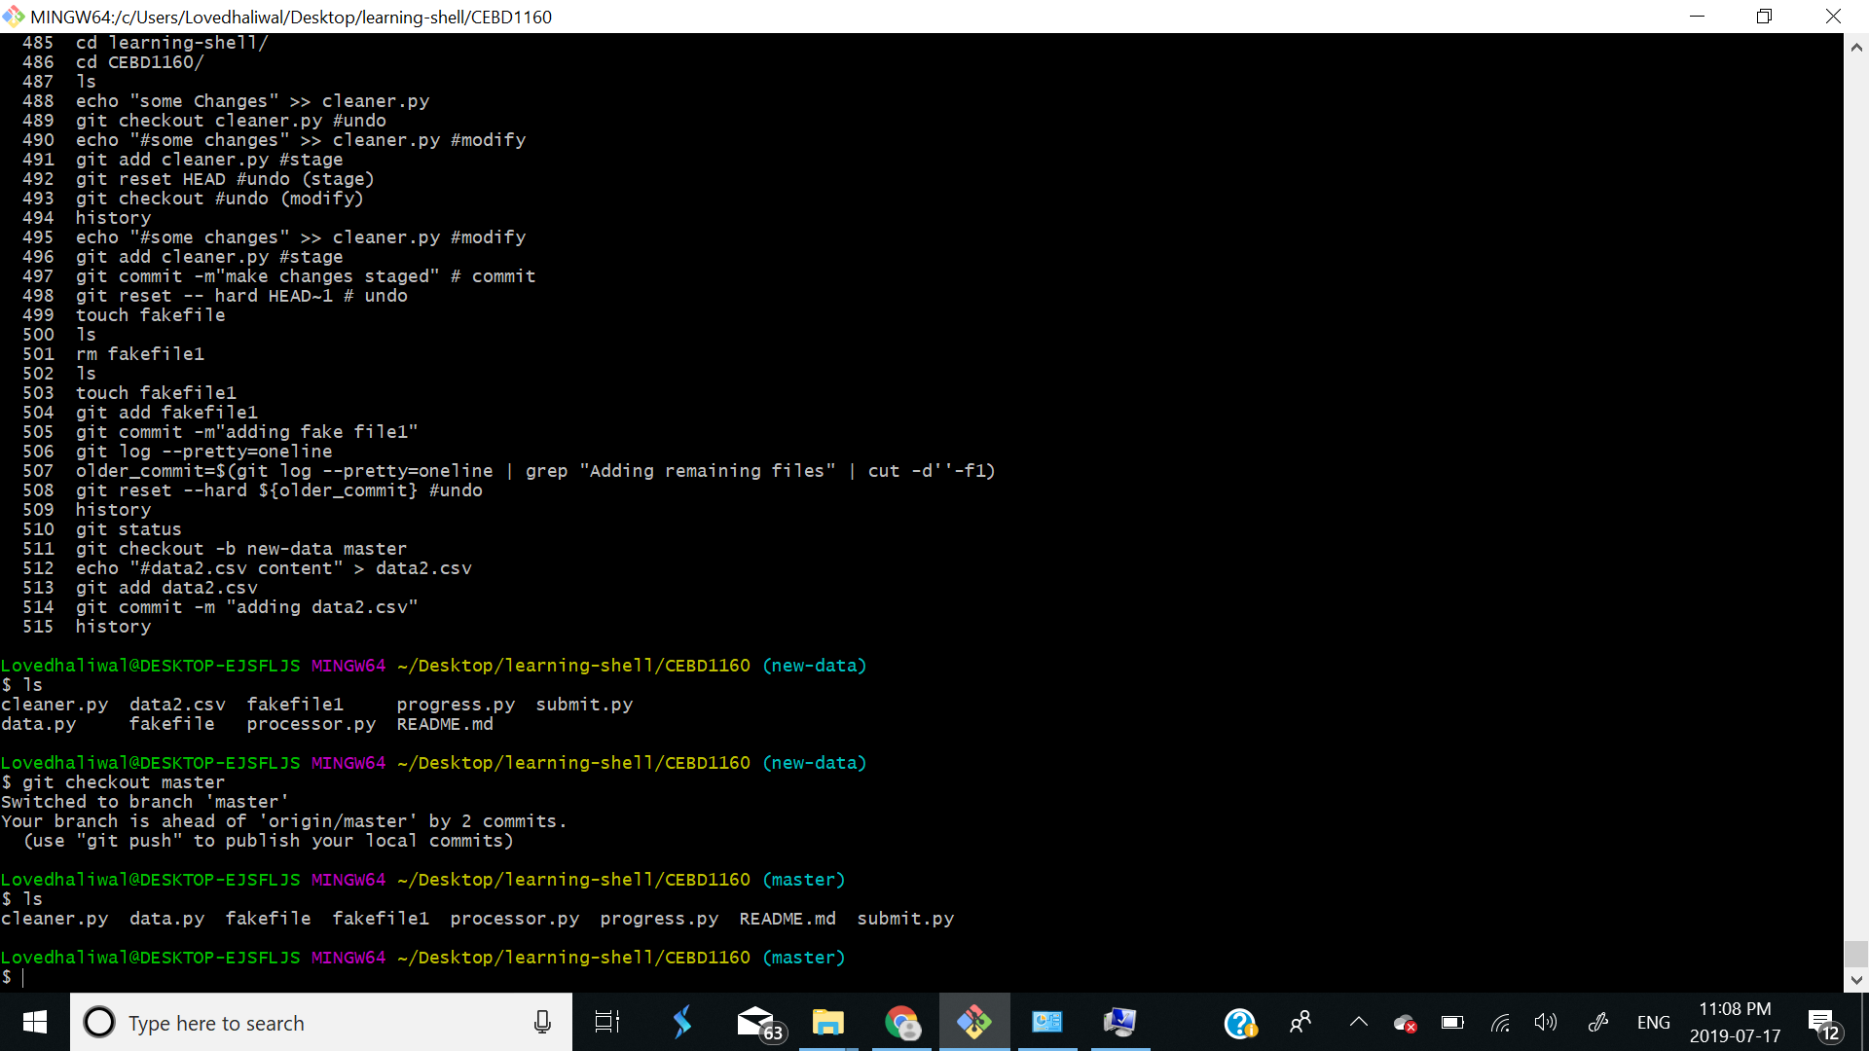

# 3- Create another branch from master and check the files that you see. Add two commits to it in any files. git ​ checkout -b another-branch master echo ​ "#some changes" ​>> cleaner.py ​ # modify

git ​ add cleaner.py git ​ commit -m​"first commit" echo ​ "#some changes" ​>> processor.py ​ # modify git ​ add processor.py git ​ commit -m​"second commit"

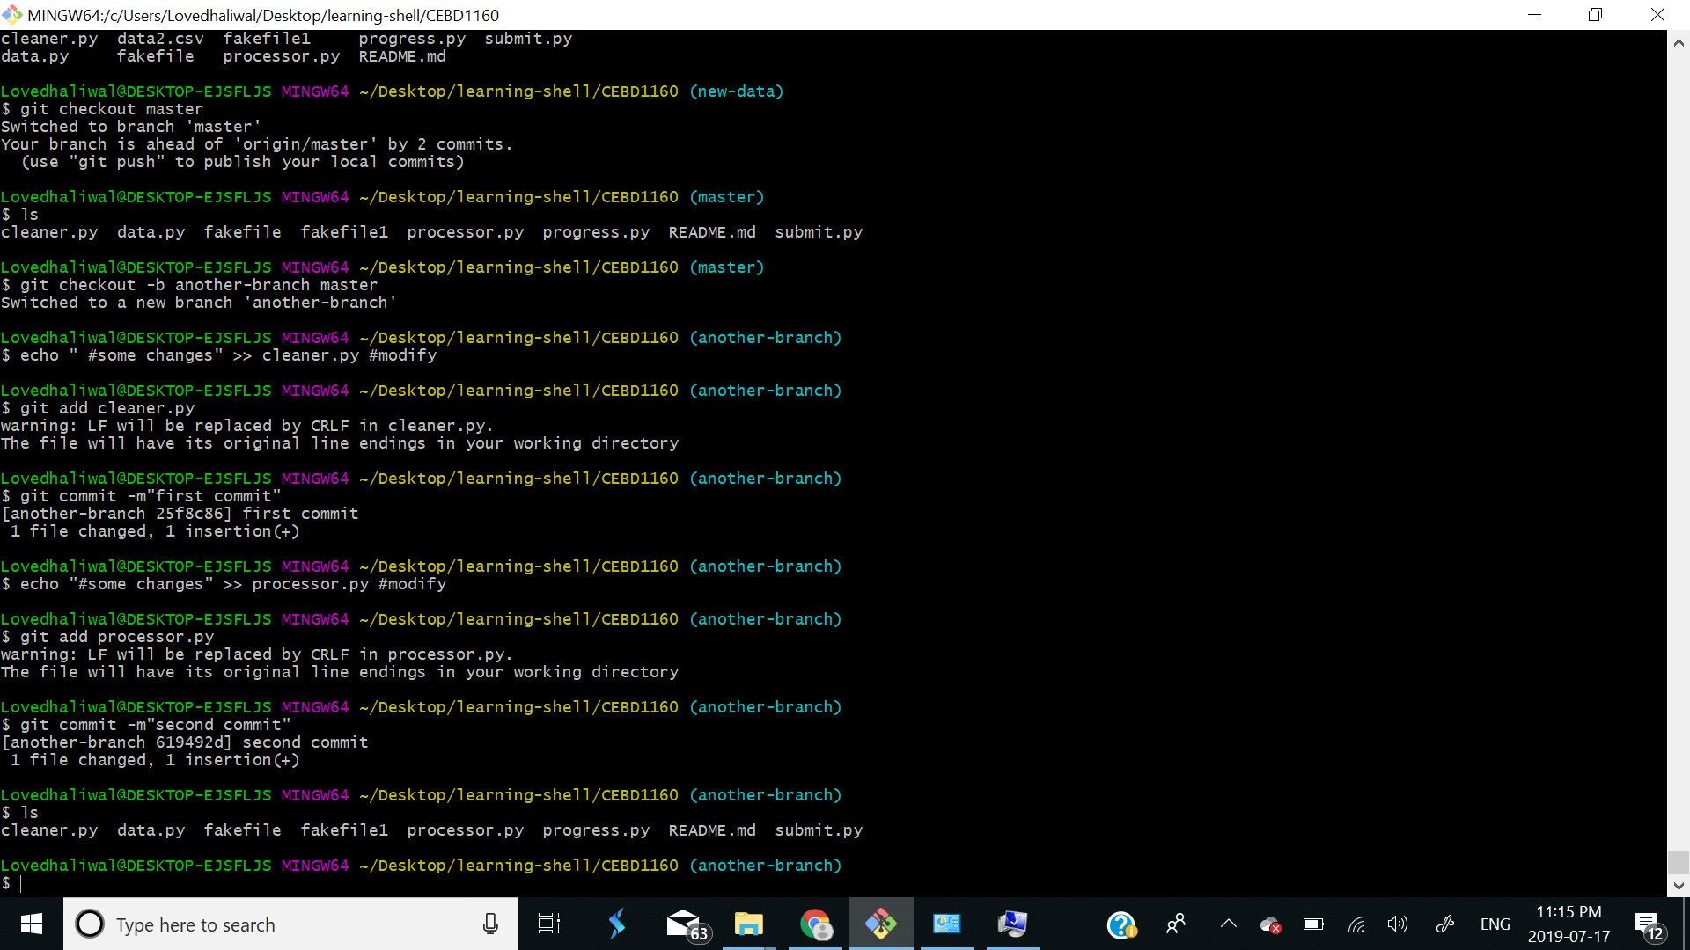

# 4- Checkout your master again and checking the files at each step, merge both branches into it. git ​ checkout master ls git ​ merge --no-edit new-data ls git ​ merge --no-edit another-branch ls

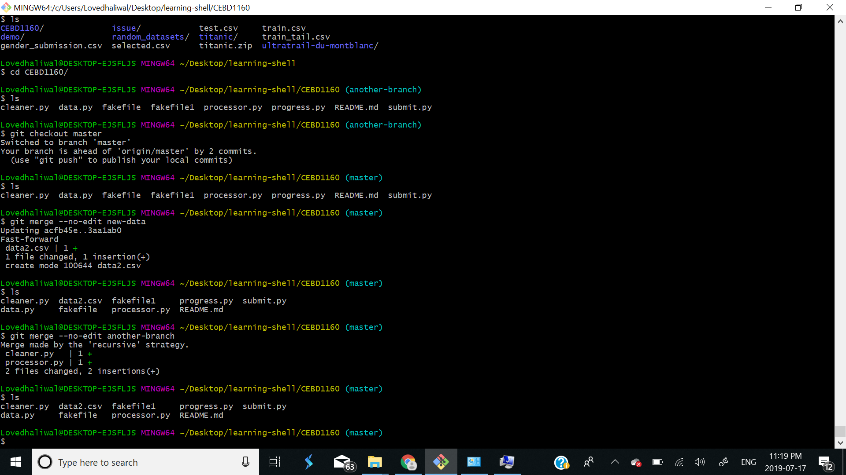

# 5- Visualize with git log --graph --oneline --decorate --all what happened. git ​ log --graph --oneline --decorate --all

